Experiment 1
Introduction to ANSYS Workbench
Name Sam Blesson S | Reg. No. 2023111073
Date 25-08-2026 | Software ANSYS Workbench (Student)

Aim
To introduce the ANSYS Workbench interface and perform a basic static structural analysis of a cantilever beam.

Software Required
ANSYS Workbench (Student / Academic Version)

Problem Statement
Analyse the deformation and stress distribution of a cantilever beam subjected to an external load using ANSYS Workbench.

Theory
Static structural analysis is used to determine the stresses, strains, and deformation caused by applied loads that do not vary with time.

Procedure
- Open ANSYS Workbench.
- Drag and drop a Static Structural system into the Project Schematic.
- Double-click Geometry and create a rectangular beam using SpaceClaim.
- Set beam dimensions: Length = 200 mm, Width = 20 mm, Height = 20 mm.
- Close and save the geometry.
- Open Model and assign Structural Steel as the material.
- Generate the mesh using default settings.
- Apply a Fixed Support at one end of the beam.
- Apply a Force of 1000 N downward at the free end.
- Solve the model.
- Insert Total Deformation and Equivalent (von-Mises) Stress and note the results.
- Change the Force to 2000 N, re-solve, and measure the maximum deformation and von-Mises stress.

Results
The maximum deformation occurs at the free end of the beam, and the maximum stress occurs near the fixed support.

For 1000 N
Total Deformation
The value of maximum deformation is 0.37532 mm.
Contour plot:
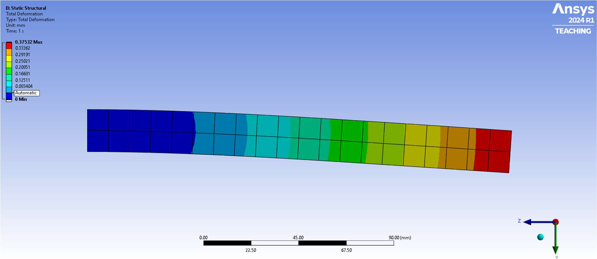
Fig. 1 — Total Deformation, 1000 N
von-Mises Stress
The value of maximum stress is 73.005 MPa.
Contour plot:
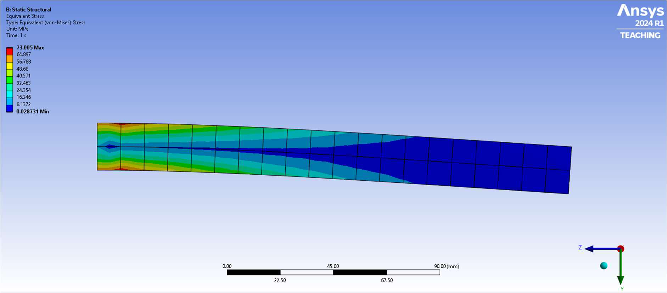
Fig. 2 — Equivalent (von-Mises) Stress, 1000 N

For 2000 N
Total Deformation
The value of maximum deformation is 0.75063 mm.
Contour plot:
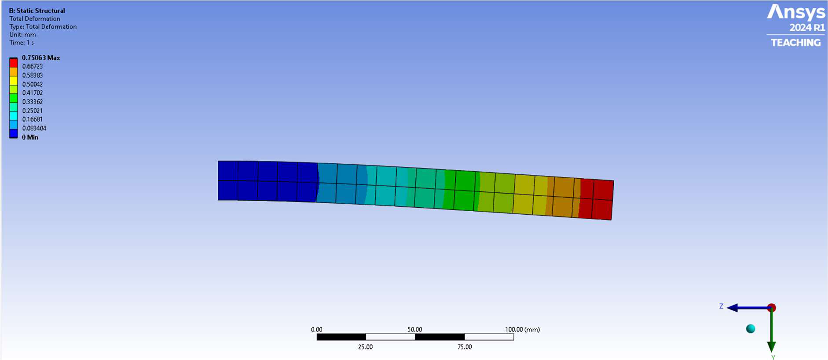
Fig. 3 — Total Deformation, 2000 N
von-Mises Stress
The value of maximum stress is 146.01 MPa.
Contour plot:
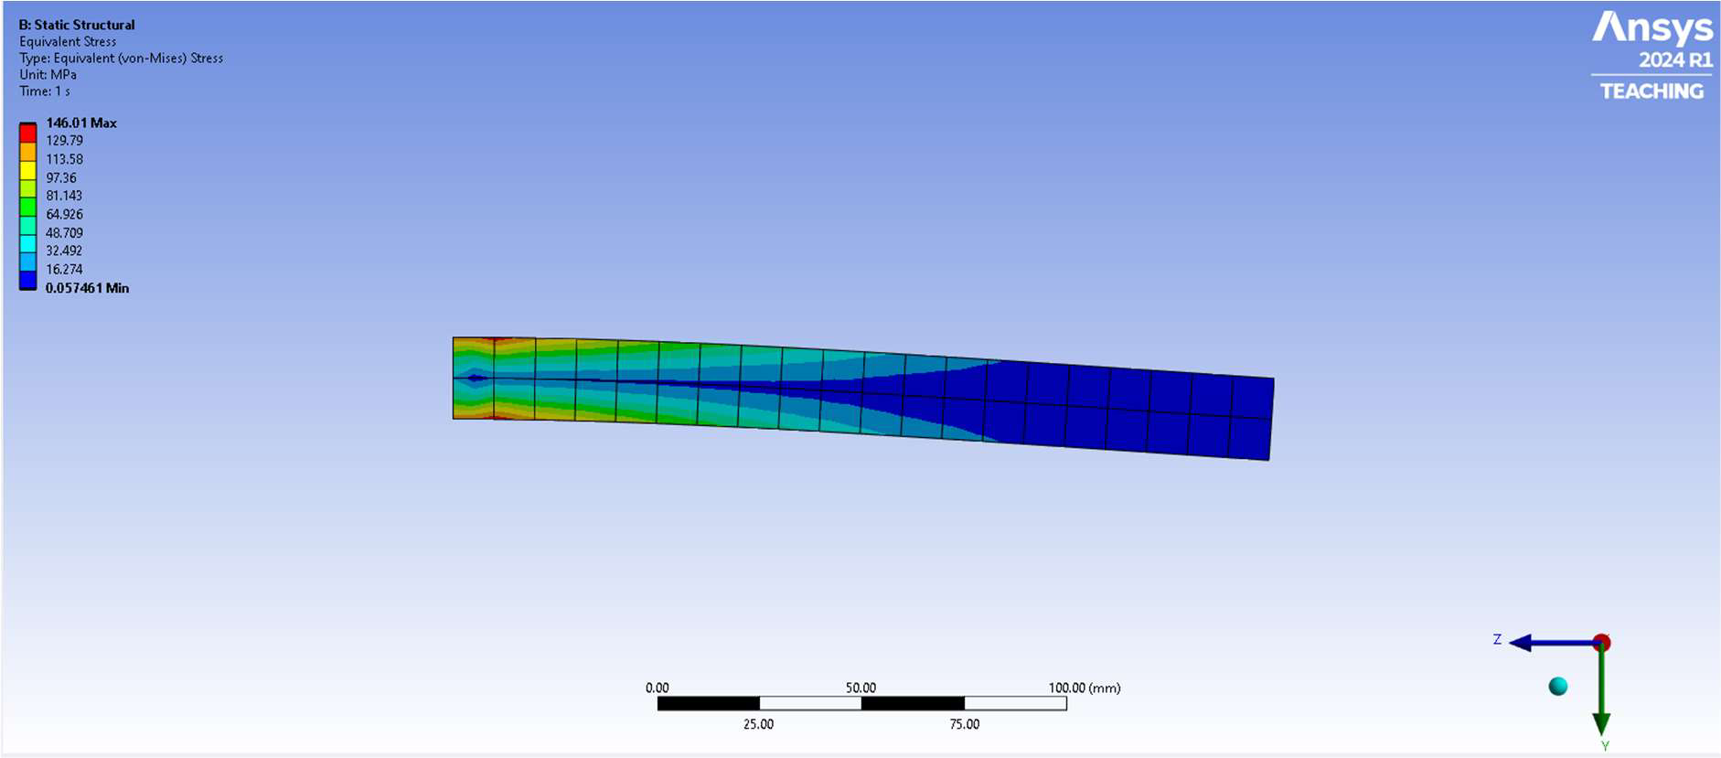
Fig. 4 — Equivalent (von-Mises) Stress, 2000 N

Summary of Results
Applied Load | Max. Total Deformation | Max. von-Mises Stress
1000 N | 0.37532 mm | 73.005 MPa
2000 N | 0.75063 mm | 146.01 MPa

Conclusion
ANSYS Workbench was successfully used to perform static structural analysis of a cantilever beam, and the resulting deformation and stress distributions were visualised for two load cases.

